Program 1: Check Whether Two Halves of a String Are Alike
Task No: 1
Aim
To determine whether the two halves of a given string contain an equal number of vowels.
Algorithm
1. Create a set containing all uppercase and lowercase vowels.
2. Find the length of the string and divide it into two halves.
3. Count vowels in the first half of the string.
4. Count vowels in the second half of the string.
5. Compare both counts.
6. If equal, return true; otherwise, return false.
Program
import java.util.Set;
import java.util.HashSet;
class Solution {
public boolean halvesAreAlike(String s) {
Set<Character> vowels = new HashSet<>();
for (char c : "aeiouAEIOU".toCharArray()) {
vowels.add(c);
}
int n = s.length();
int mid = n / 2;
int countA = 0;
int countB = 0;
for (int i = 0; i < mid; i++) {
if (vowels.contains(s.charAt(i))) {
countA++;
}
if (vowels.contains(s.charAt(i + mid))) {
countB++;
}
}

return countA == countB;
}
}
Output
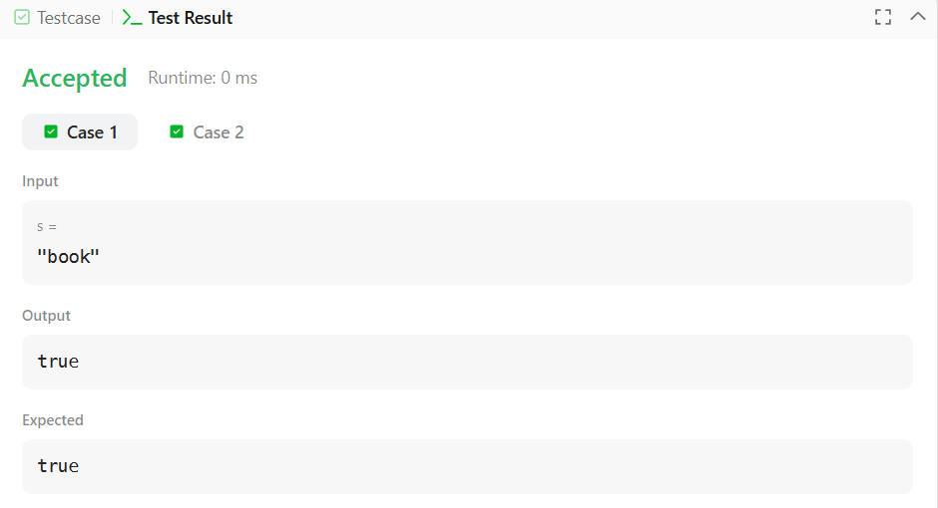

Result
The program successfully checks whether both halves of the string contain the same number of vowels.

Program 2: Check Whether a String Is a Lapindrome
Task No: 2
Aim
To check whether a given string is a Lapindrome (both halves have the same character frequency).
Algorithm
- Read the number of test cases.
- For each string:
  - Count character frequencies in the first half.
  - Subtract frequencies of characters in the second half.
- Ignore the middle character if the string length is odd.
Program
import java.util.*;
import java.lang.*;
import java.io.*;
class Codechef {
public static void main (String[] args) throws java.lang.Exception {
Scanner sc = new Scanner(System.in);
int T = sc.nextInt();
while (T-- > 0) {
String s = sc.next();
System.out.println(isLapindrome(s) ? "YES" : "NO");
}
sc.close();
}
private static boolean isLapindrome(String s) {
int n = s.length();
int[] freq = new int[26];
for (int i = 0; i < n / 2; i++) {
freq[s.charAt(i) - 'a']++;
}
int start = (n % 2 == 0) ? n / 2 : n / 2 + 1;
for (int i = start; i < n; i++) {
freq[s.charAt(i) - 'a']--;
}
for (int count : freq) {
if (count != 0) {
return false;
}
}
return true;
}
}
Output
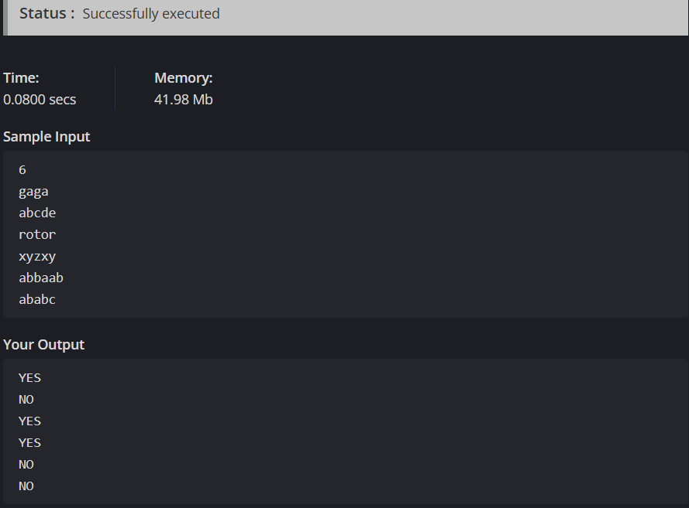

Result
The program correctly identifies whether a string is a Lapindrome.
Program 3: Compare Triplets
Task No: 3
Aim
To compare two triplets and calculate scores for Alice and Bob based on their values.
Algorithm
- Initialize scores for Alice and Bob as zero.
- Compare corresponding elements of both triplets.
- Increment Alice’s score if her value is greater.
- Increment Bob’s score if his value is greater.
- Store and return both scores as a list.
Program
import java.io.*;
import java.util.*;
import java.util.stream.*;
class Result {
public static List<Integer> compareTriplets(List<Integer> a, List<Integer> b) {
int alice = 0;
int bob = 0;
for (int i = 0; i < 3; i++) {
if (a.get(i) > b.get(i)) {
alice++;
} else if (a.get(i) < b.get(i)) {
bob++;
}
}

List<Integer> result = new ArrayList<>();
result.add(alice);
result.add(bob);
return result;
}
}
public class Solution {
public static void main(String[] args) throws IOException {
BufferedReader bufferedReader = new BufferedReader(new InputStreamReader(System.in));
List<Integer> a = Stream.of(bufferedReader.readLine().split(" "))
.map(Integer::parseInt)
.collect(Collectors.toList());
List<Integer> b = Stream.of(bufferedReader.readLine().split(" "))
.map(Integer::parseInt)
.collect(Collectors.toList());
List<Integer> result = Result.compareTriplets(a, b);
System.out.println(result.get(0) + " " + result.get(1));
}
}
Output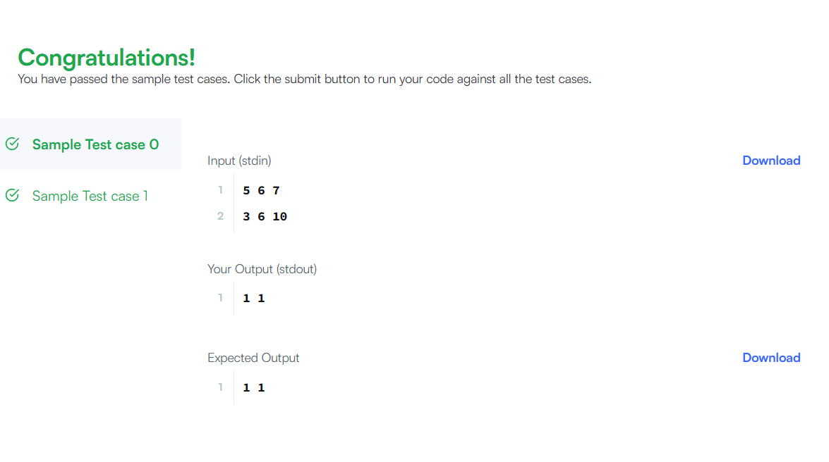
Result
The program outputs the correct comparison scores for Alice and Bob.

Program 4: Check for Duplicate Elements in an Array
Task No: 4
Aim
To determine whether an integer array contains any duplicate elements.
Algorithm
- Create an empty hash set.
- Traverse the array elements.
- Add each element to the set.
- If insertion fails, a duplicate exists.
- Return true if duplicate found, else false.
Program
import java.util.HashSet;
import java.util.Set;

class Solution {
public boolean containsDuplicate(int[] nums) {
Set<Integer> seen = new HashSet<>();
for (int num : nums) {
if (!seen.add(num)) {
return true;
}
}
return false;
}
}
Output
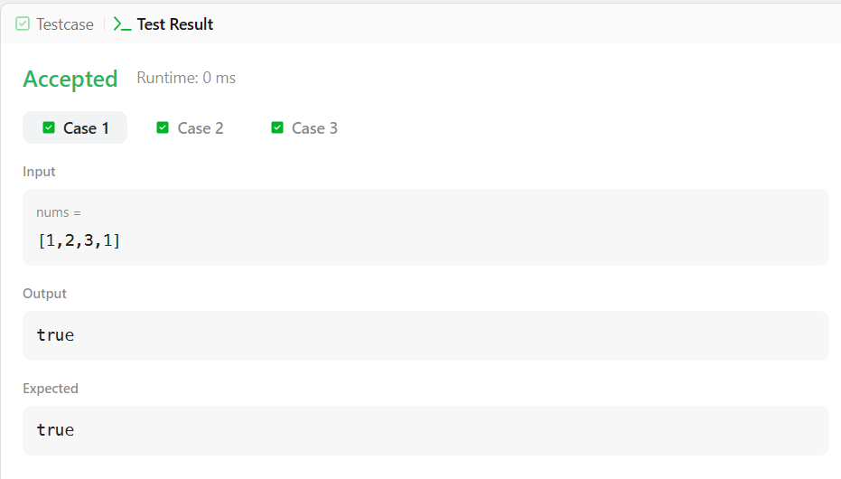

Result
The program successfully detects whether duplicate values are present in the array.

